Login Form

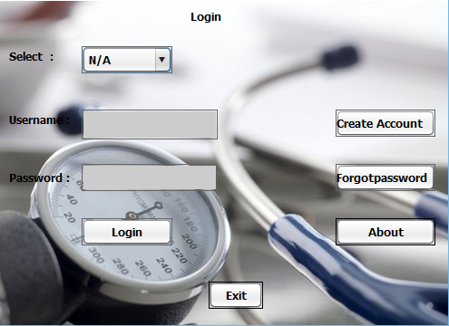

The login form is necessary to secure the hospital data or the patient data .The login form contain an user name and password. The admin when enter the username and password then the entire information related to the admin will be display. If the admin is doctor then doctor will get the data related to the doctor itself other d ata will be hidden from the doctor .Here in the LOGIN FORM fig we can see that the enter user name have the combobox where we can see the list of different username when we click the combobox. Different password allotted to different user hence the hospital database is secure .In this case the data will be retrieve from the database when user login so that the related data will be shown to the respective user. we seen the login form of the project which is important for securing the data .The user can change the password and if user forgot the password then user gain that password after the confirmation .The confirmation of the user will done when information of the user will match with the data present in the database regarding the user .Due to this login form the management of hospital management is easier than earlier days at that time the entire record was maintain in the manual record.

Inert Image

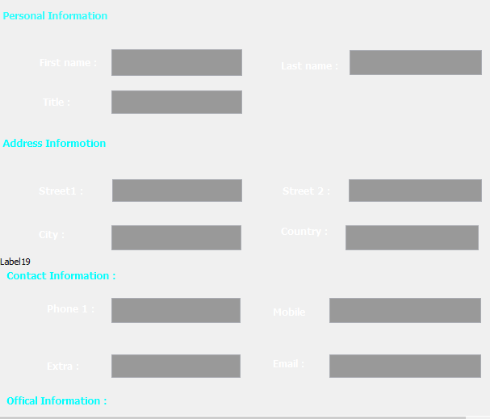

First time I can’t insert background image and finally I can it.

Than my project close after work and open this project when image not found than solve it .import project open my image than it save always.

Home Page

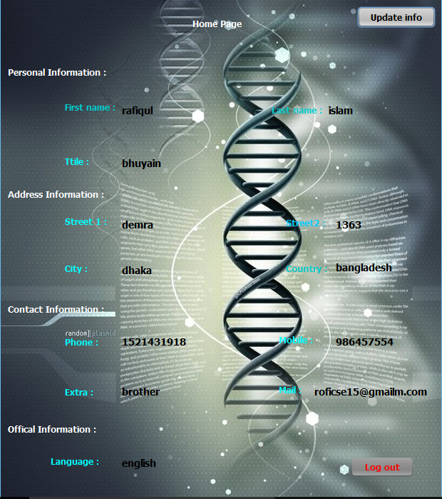

Home page form contain list of the entire data include in the project different modules we can see and each module contain its respective forms the modules include in the project are staff, patient ,report, bill, etc. the homepage contain all this . when we click on the staff we get the doctor form, nurse form, and other form (workers ,accountant ,etc). Patient contain the information related to the patient when click the patient we get different form admit card, operation ,discharge, room change etc. Next form is Report when we click the report we get the data related to the report such as blood report, urine report, etc In this form the data relate to hospital management is store .Staff, Patient , Report, User, About Project .we see that the the data relate all this menu will save in the database.

Update Info



When work finished update info than data input suddenly notice only username input and other option is empty data table input empty.

So it solve easily bye if else condition.

>8 Password

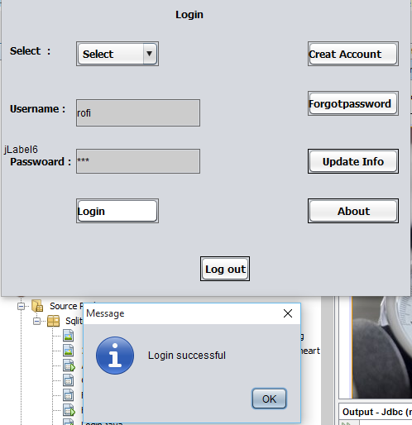

User cannot sing up password less then 8 word but it sing up less than 8 word password. Than it solve by string length formula.

Insert Data



User data input from create account page when input not data SQL data table. than I found out the problem this is create account page text field total number and SQL Colum number same than data input complete.

Combo Box

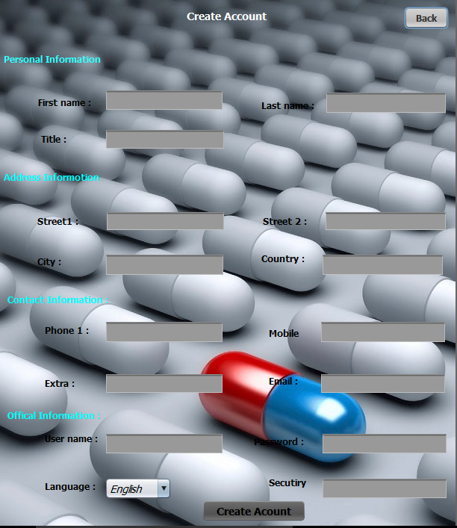

When click create account page button of sing up but data not input text field inspirit of account is create.

So solve it combox option.

One of the alternative solutions is the improvement of the manual system.

Anything, which can be done by using automated methods, can be done

manually. But the question arises how to perform thing manually in a sound

manner. Following are some suggestions, which can be useful in the manual

system.

A more sophisticate register maintenance for various Patient Information, Doctor

diary, Immunization Details and a good system for writing bill amount

employees and stock availed for the customers can be maintained at central place.

Adequate staff may be maintained so that updations are made at the very moment

at the same time. Proper person for proper work should be made responsible so

that a better efficiency could be achieved. This needs a lot of work force.

Another alternative solution can be used of computer based batch system for

maintaining the information regarding purchase details, customers and

employees. A batch system refers to a system in which data is processed in a

periodical basis.

The batch system is able to achieve most of the goals and sub goals. But a batch

system data is processed in sequential basis. Therefore batch system is not

suggested.

About

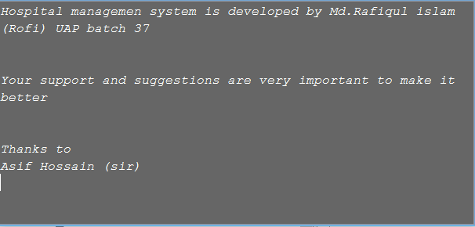

When write about jFrome than problem face write down .

Than it solve text area field than write about Jfrom.